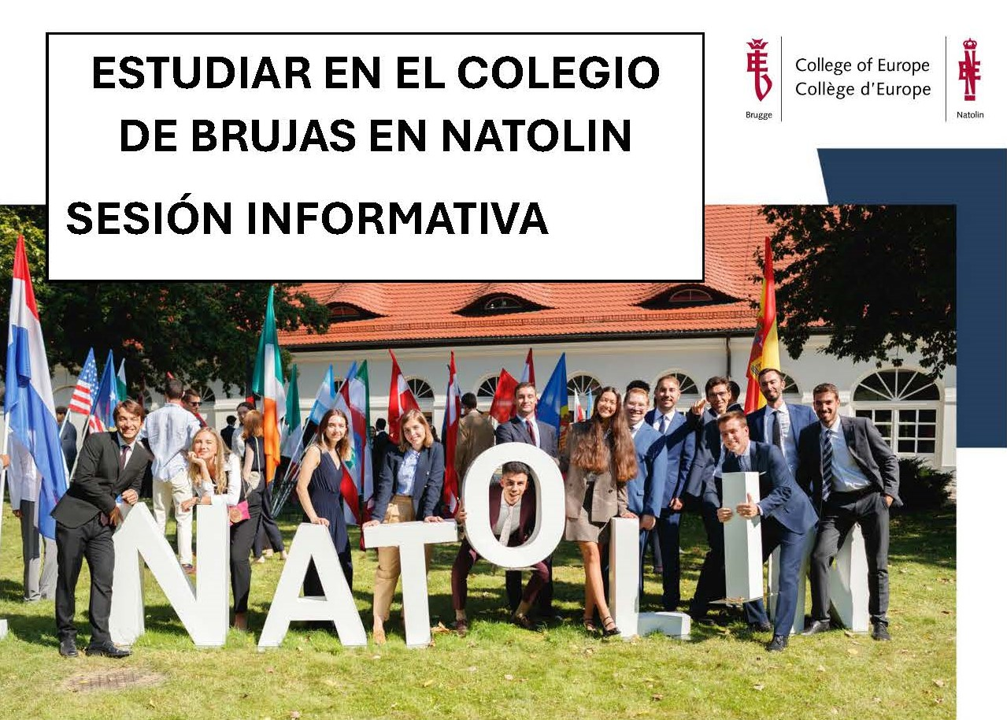

Discover the College of Europe in Natolin and its new study track in European Security and Strategy

Applications for the 2026/27 academic year at the College of Europe are now open and we are proud to present a new study track at Natolin in European Security and Strategy within the Advanced Master of Arts in European Interdisciplinary Studies.

📅 Date: 20 November 2025
🕒 Time: 19:00
📍 Location: Edificio San Pedro - Aula 1.05

Join us to learn more about:

The new European Security and Strategy study track
Other available majors:
• EU Public Affairs and Policies
• The EU and the World
• The EU in the Wider Europe and its Neighbours
• European History and Civilization
How the College of Europe in Natolin can prepare you for international careers
Scholarships (over 70% of students receive financial support)
Application process and tips for preparing a strong application (deadline: 14 January 2026)

